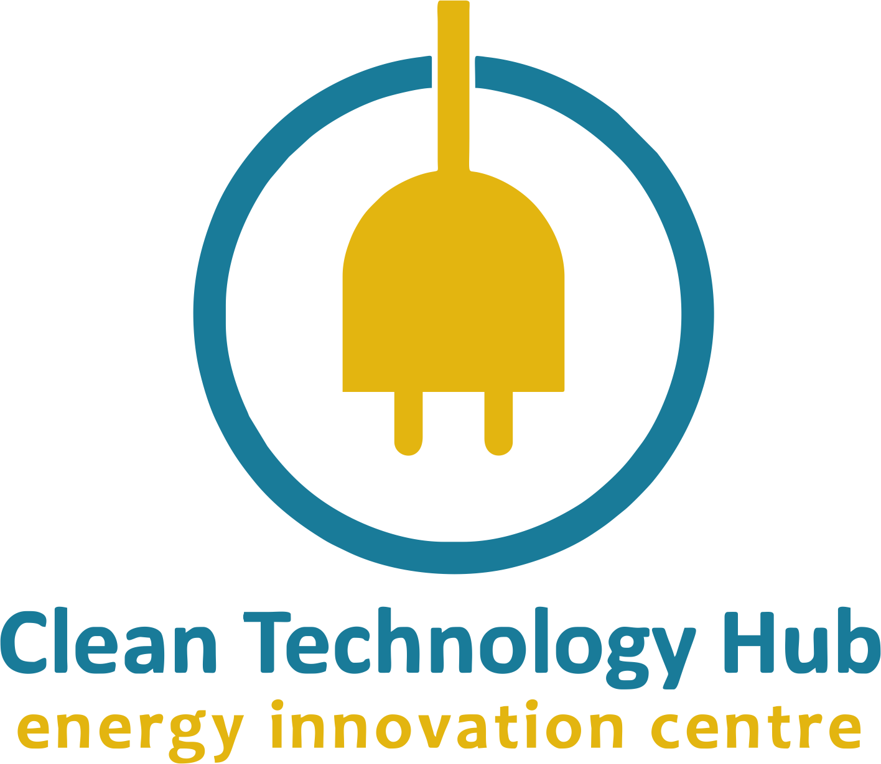

Director of Innovation and Partnerships

The Company
Clean Tech Hub is a pioneering hybrid hub for the research, development, demonstration and incubation of clean energy technologies in Africa, and their validation for commercial stage development. It is an early start-up incubator for inventions and innovations in clean energy, a consultancy for sustainability and energy efficiency solutions for organizations, and a driver of clean energy investment into Africa. Clean Tech Hub is focused on addressing Africa’s energy poverty, increasing energy access through clean, renewable energy and sustainability.

Position Summary
Clean Tech Hub is seeking to recruit a results-driven Head of Innovation and Partnerships who will be responsible for increasing creative capacity to develop and secure projects, in addition to managing the Hub’s external relationships with our diverse range of donors and stakeholders. The Head of Innovation and Partnerships will be responsible for building and managing relationships with other partners as well as oversee all fundraising efforts and activities with particular focus on sustainable growth opportunities within the development sector.

Responsibilities
- Developing a clear growth strategy and targets for partnership and fundraising at CTH.
- Carrying out research and evaluation plans for new growth opportunities.
- Analyzing current industry trends to identify business opportunities that would generate revenue resources and profitability.
- Developing and implementing the operational plan which drives the Innovation Partnership department and determines its success.
- Developing and implementing a partnership strategy to increase the reach and impact of our ongoing efforts in advancing CTH’s vision and mission
- Conceptualizing new strategic initiatives that could be built around or benefit from corporate, foundation, government, bilateral organizations or other partnerships.
- Negotiating attractive partnership deals and ensuring mutually beneficial partnership terms that are in line with business objectives and strategy.
- Maintaining and deepening relationships with existing partners.
- Building awareness and adoption of CTH’s product offers through client presentations and conference attendance.
- Proposal development, build detailed brief and pitch ideas to multiple stakeholders.
- Maintaining and developing new projects, programs, and initiatives for the organization.
- Proposal development, build detailed brief and pitch ideas to multiple stakeholders.
- Fundraising ventures, stakeholder engagements and building partnerships.
Essential knowledge and Requirements
- Must be committed and passionate about CTH’s goal, objectives and mission.
- At least 5+ years proven experience in business development/strategic partnerships management or any related line of work.
- Highly knowledgeable in current trends as it relates to energy access and environmental and climate action.
- Strong networking and negotiation skills.
- Experience in building partnerships with local and international development donors.
- Skilled at assessing and managing grants/ project budgets and donor funds.
- Proposal writing and grant applications
- Demonstrable competency in strategic planning and business development.
- A strategic mind that is focused on execution.
- Demonstrable ability to work creatively and analytically in a problem-solving environment.
- Ability to multitask, set priorities and manage time effectively.
- An excellent communicator – both written and oral, a critical thinker with an analytical approach to information – and able to present and pitch to multiple stakeholders.
- Understanding of advanced business planning and regulatory issues.
- A solid grasp of data analysis and performance metrics.
- High level of proficiency, in MS Office and experience of working with information management systems/ databases.
Who you are
- A self- starter who is able to learn, work independently and passionately.
- You seek to take on new types of work, even without supervision.
- You show willingness to work, travel, and do what it takes to get the job done.
- You are comfortable with ambiguity and an ability to operate effectively in a changing context.
- You are able to react with appropriate levels of urgency to situations and events that require quick response.
- You can build strong relationships with clients and colleagues in a high paced environment.
- You have a healthy dose of curiosity, innovation in delivery and timely delivery in tasks.
- You must speak and write well and have a reasonably good command of English language usage and structure.

Preferred Qualifications
- Proven track record in forming effective relationships with a range of local and international partners.
- Fundraising experience.
- Advanced writing and proof-reading skills.
- An international development experience is an advantage.
For interested applicants, follow the link to our jobs form here:

